Code:

from CS312Graph import *  
import time  
import sys  
  
class NetworkRoutingSolver:  
 def __init__( self, display ):  
 pass  
  
 def initializeNetwork( self, network ):  
 assert( type(network) == CS312Graph )  
 self.network = network

// O(n) – worst case. This loops through one path of nodes(could visit each node)  
 def getShortestPath( self, dest_index ):  
 self.dest = dest_index  
 path_edges = []  
 total_length = 0  
 self.cur_node = self.queue.nodes[self.dest]  
 while(self.cur_node.node_id != self.source):  
 cur_loc = self.cur_node.loc  
 prev = self.queue.get_prev_node(self.cur_node)  
 if(prev != None):  
 prev_loc = prev.loc  
 else:  
 break  
 length = self.queue.get_prev_length(self.cur_node)  
 path_edges.append((cur_loc, prev_loc, '{:.0f}'.format(length)))  
 self.cur_node = self.queue.get_prev_node(self.cur_node)  
 total_length += length  
  
 return {'cost':total_length, 'path':path_edges}

// Thus total is O((n + e)*log(n))

def computeShortestPaths( self, srcIndex, use_heap=False ):  
 self.source = srcIndex  
 t1 = time.time()  
 if(use_heap):

//O(n)  
 self.queue = Heap(self.network, srcIndex)  
 else:

//O(n)  
 self.queue = Array(self.network, srcIndex)

//Repeats edges times   
 while(not self.queue.queue_empty()):  
 lowest_node = self.queue.delete_min()  
 if(lowest_node == -1):  
 break  
  
 if(lowest_node.node_id != 0):

// O(n) Ends up being n since reaches total for all the nodes  
 self.queue.push_neighbors_on_queue(lowest_node)

neighbors = lowest_node.neighbors

// O(E) since it visits all the edges for each nodes   
 for i in range(0, len(neighbors)):  
 if(self.queue.get_distance_to(neighbors[i].dest) >

self.queue.get_distance_to(lowest_node) + neighbors[i].length):  
 self.queue.set_distance_to(neighbors[i].dest,

self.queue.get_distance_to(lowest_node) + neighbors[i].length)  
 self.queue.set_prev_node(neighbors[i].dest, lowest_node)  
 self.queue.decrease_key()  
  
 t2 = time.time()  
  
 return (t2-t1)

class Heap:

//O(n) This only calls insert and makes lists the size of the nodes in the graph  
 def __init__(self, graph, src):  
 def __init__(self, graph, src):  
 self.nodes = graph.nodes  
 self.queue = list()  
 self.queue_size = 0  
 self.node_dist = [sys.maxsize-1]*len(self.nodes)  
 self.prev_node = [None]*len(self.nodes)  
 self.popped_nodes = list()  
  
 self.insert(CS312GraphEdge(self.nodes[src], self.nodes[src], 0))  
 self.node_dist[src] = 0  
 self.prev_node[src] = self.nodes[src]  
 self.push_neighbors_on_queue(self.nodes[src])  
  
 pass

//O(log(n)) This function gets called on just the 3 neighbors of the function and calls sift up for each of them  
 def push_neighbors_on_queue(self, node):  
 for i in range(len(node.neighbors)):  
 if(node.neighbors[i].dest.node_id not in self.popped_nodes):  
 self.insert(node.neighbors[i])  
 self.sift_up(self.queue_size-1)  
//O(1)  
 def insert(self, edge):  
 self.queue.append(edge)  
 self.queue_size = self.queue_size + 1

//O(Log(n) It repeats the height of the tree which is log(n)  
 def sift_up(self, i):  
 parent = (i-1) // 2  
 while i != 0 and self.node_dist[self.queue[i].dest.node_id] <

self.node_dist[self.queue[parent].dest.node_id]:  
 temp = self.queue[parent]  
 self.queue[parent] = self.queue[i]  
 self.queue[i] = temp  
 i = parent  
 parent = (i - 1) // 2

//O(Log(n) It uses the sift down function which is Log(n)  
 def delete_min(self):  
 if (self.queue_empty()):  
 return -1  
  
 return_node = self.queue[0].dest  
 self.queue[0] = self.queue[-1]  
 self.queue.pop()  
 self.popped_nodes.append(return_node.node_id)  
 self.queue_size = self.queue_size - 1  
 self.sift_down(0)  
  
 return return_node

// O(log(n) This is Log(n) as it starts as the vertex of the tree and only visits its children until it hits the bottom which is Log(n) levels thus O(log(n)

def sift_down(self, i):  
 if(not self.queue_empty()):  
 while (i * 2) < len(self.queue):  
 min_child = self.min_child(i)  
 if(min_child == -1):  
 break  
 if (self.node_dist[self.queue[i].dest.node_id] >

self.node_dist[self.queue[min_child].dest.node_id]):  
 temp = self.queue[i]  
 self.queue[i] = self.queue[min_child]  
 self.queue[min_child] = temp  
 i = min_child

//This function just looks at the two children and returns its lowest value child. O(1)  
 def min_child(self, i):  
 left_child = i * 2 + 1  
 right_child = i * 2 + 2  
 if left_child >= len(self.queue):  
 return -1  
 elif right_child >= len(self.queue):  
 return left_child  
 else:  
 if self.node_dist[self.queue[left_child].dest.node_id] <

self.node_dist[self.queue[right_child].dest.node_id]:  
 return left_child  
 else:  
 return right_child

//O(1)  
 def queue_empty(self):  
 if (len(self.queue) > 0):  
 return False  
 else:  
 return True  
//O(1)  
 def get_distance_to(self, node):  
 return self.node_dist[node.node_id]  
//O(1)  
 def get_prev_length(self, node):  
 if (self.prev_node[node.node_id] != None):  
 return self.node_dist[node.node_id] –

self.node_dist[self.prev_node[node.node_id]]  
 else:  
 return 0  
//O(1)  
 def get_prev_node(self, node):  
 if (self.prev_node[node.node_id] != None):  
 return self.nodes[self.prev_node[node.node_id]]  
//O(1)  
 def set_distance_to(self, node, distance):  
 self.node_dist[node.node_id] = distance  
//O(1)  
 def set_prev_node(self, node, prev_node):  
 self.prev_node[node.node_id] = prev_node.node_id  
//O(1)  
 def decrease_key(self):  
 return True

//O(1)

class Array:

//O(n) This only calls insert and makes lists the size of the nodes in the graph  
 def __init__(self, graph, src):  
 self.graph = graph  
 self.nodes = graph.getNodes()  
 self.node_dist = list()  
 self.prev_node = list()  
 self.popped_nodes = list()  
 self.queue = list()  
 nodes = graph.getNodes()

// This for loop is O(n) as it repeats for the number of nodes  
 for i in range(len(nodes)):  
 if(nodes[i].node_id == src):  
 self.queue.append(CS312GraphEdge(nodes[i], nodes[i], 0))  
 self.push_neighbors_on_queue(nodes[i])  
 self.node_dist.append(0)  
 self.prev_node.append(src)  
 else:  
 self.node_dist.append(sys.maxsize-1)  
 self.prev_node.append(None)

// This is O(n) total   
 def push_neighbors_on_queue(self, node):  
 for i in range(0,len(node.neighbors)):  
 if(node.neighbors[i].dest.node_id not in self.popped_nodes):  
 self.queue.append(node.neighbors[i])

// O(1)  
 def queue_empty(self):  
 if(len(self.queue) > 0):  
 return False  
 else:  
 return True

// O(  
 def delete_min(self):  
 temp_highest = sys.maxsize  
 node_index = -1  
 queue_index = -1  
 for i in range(len(self.queue)):  
 if(self.node_dist[self.queue[i].dest.node_id] < temp_highest  
 and self.queue[i].dest.node_id not in self.popped_nodes):  
 temp_highest = self.node_dist[self.queue[i].dest.node_id]  
 node_index = self.queue[i].dest.node_id  
 queue_index = i  
  
 if(node_index == -1):  
 return -1  
 else:  
 return_node = self.queue[queue_index].dest  
 self.queue.pop(queue_index)  
 self.popped_nodes.append(return_node.node_id)  
 return return_node  
  
 def get_distance_to(self, node):  
 return self.node_dist[node.node_id]  
  
 def set_distance_to(self, node, distance):  
 self.node_dist[node.node_id] = distance  
  
 def get_prev_node(self, node):  
 if (self.prev_node[node.node_id] != None):  
 return self.nodes[self.prev_node[node.node_id]]

def set_prev_node(self, node, prev_node):  
 self.prev_node[node.node_id] = prev_node.node_id  
  
 def get_prev_length(self, node):  
 if (self.prev_node[node.node_id] != None):  
 return self.node_dist[node.node_id] - self.node_dist[self.prev_node[node.node_id]]  
 else:  
 return 0  
  
 def decrease_key(self):  
 return True

Complexity Analysis:

Array: Making the queue is (n). Inserting is O(1). Deleting the Min is O(n). Decreasing the Key doesn’t do much

Thus the total time complexity is n + n + n(n) + e(1) = O(n^2 + e)

Heap: Making the queue is n. Inserting comes to log(n). Deleting in is log(n). Decreasing key runs at log(n)

Thus the total time complexity is n + log(n) + n*log(n) + elog(n) = O((n + e)*log(n))

Drawing the shortest path yields O(n) added to each of the implementations.

So it is either

O((n + e)*log(n) + n) Or O(n^2 + e + n)

Space Complexity:

The algorithm keeps 2 arrays of size n for total distances and previous nodes thus O(2n)

Array: The array implementation stores another 3 arrays of size n for the graph, nodes, and popped nodes. Thus total space is O(5n)

Heap: The heap implementation also stores another 3 arrays. Thus is is the same space complexity O(5n).

Screenshots:

There is no path.

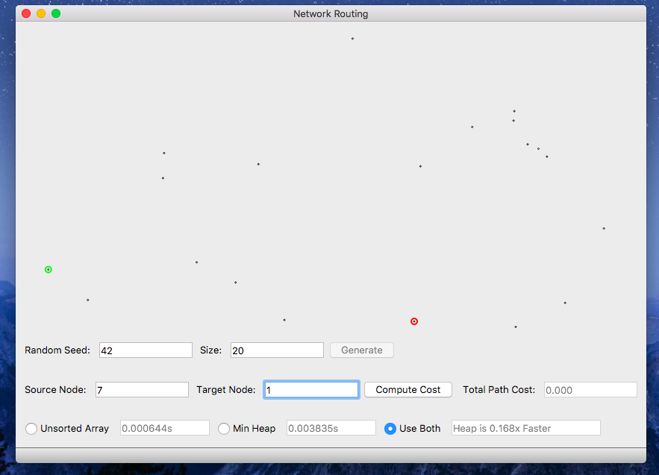

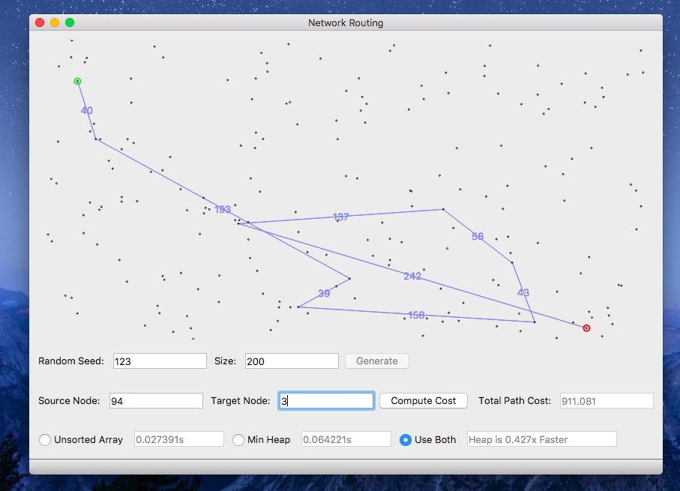

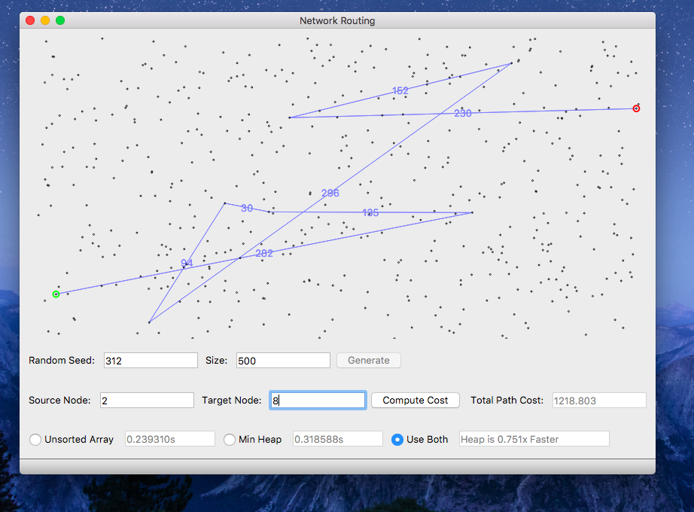

Graph and Chart:

|  |  |  |  |  |  |  |  |
| --- | --- | --- | --- | --- | --- | --- | --- |
| Array: Seed: 312 |  | Trial1 | Trial 2 | Trial 3 | Trial 4 | Trial5 | Avg |
|  | 100 | 0.009675 | 0.0078 | 0.00789 | 0.00743 | 0.00833 | 0.008225 |
|  | 1000 | 1.658 | 1.903 | 1.734 | 1.674 | 1.926 | 1.779 |
|  | 10000 | 1798.54 | 1711.89 | 1726.45 | 1753.27 | 1705.66 | 1739.162 |
|  | 100000 |  |  |  |  |  |  |
|  | 1000000 |  |  |  |  |  |  |

|  |  |  |  |  |  |  |  |
| --- | --- | --- | --- | --- | --- | --- | --- |
| Heap: Seed: 312 |  | Trial1 | Trial 2 | Trial 3 | Trial 4 | Trial5 | Avg |
|  | 100 | 0.01977 | 0.1006 | 0.0207 | 0.0375 | 0.0239 | 0.040494 |
|  | 1000 | 0.856 | 0.8695 | 0.8496 | 0.8471 | 1.006 | 0.88564 |
|  | 10000 | 86.68 | 86.45 | 86.77 | 86.34 | 86.1 | 86.468 |
|  | 100000 |  |  |  |  |  |  |
|  | 1000000 |  |  |  |  |  |  |

For some reason the program wouldn’t run in an efficient manner on my laptop when running the higher node counts so I couldn’t complete the time trials. But these are the graphs projecting the higher node count run times:

Array:

Heap: